To establish learning ambience for ushering in computer engineering professionals in core and multidisciplinary area by developing Problemsolving skills through emerging technologies.

Session 2025-2026

Vision: To be a well-known centre for pursuing computer education through innovative pedagogy, value-based education and industry collaboration | Mission: To establish learning ambience for ushering in computer engineering professionals in core and multidisciplinary area by developing Problem-solving skills through emerging technologies.

Program Educational Objectives of the program (PEO): (broad statements that describe the professional and career accomplishments)
PEO1 | Preparation | P: Preparation | Pep-CL abbreviation pronounce as Pep-si-lL easy to recall
PEO2 | Core Competence | E: Environment  (Learning Environment)
PEO3 | Breadth | P: Professionalism
PEO4 | Professionalism | C: Core Competence
PEO5 | Learning  Environment | L: Breadth (Learning in diverse areas)

Program Outcomes (PO): (statements that describe what a student should be able to do and know by the end of a program)
Keywords of POs:
Engineering knowledge, Problem analysis, Design/development of solutions, Conduct Investigations of Complex Problems, Engineering Tool Usage, The Engineer and The World, Ethics, Individual and Collaborative Team work, Communication, Project Management and Finance, Life-Long Learning

PSO Keywords: Cutting edge technologies, Research

“I am an engineer, and I know how to apply engineering knowledge to investigate, analyse and design solutions to complex problems using tools for entire world following all ethics in a collaborative way with proper management skills throughout my life.” to contribute to the development of cutting-edge technologies and Research.

Integrity: I will adhere to the Laboratory Code of Conduct and ethics in its entirety.

Name and Signature of Student and Date
(Signature and Date in Handwritten)

To establish learning ambience for ushering in computer engineering professionals in core and multidisciplinary area by developing Problemsolving skills through emerging technologies.

Session | 2025-26 (EVEN) | Course Name | JAVA FSD Lab
Semester | 4th | Course Code | 23ADS1407
Roll No | 120  121  122 | Name of Students | Shrusti katakwar  Sonali Pingale  Srushti Bongane

Practical Name | MINI PROJECT
Course Outcome | - Understand how to store and manage student data.  - Create a system to add, update, delete, and search student records.  - Calculate student grades based on marks.  - Develop a basic application using programming skills.  - Maintain accurate and organized student information.  • Test the system to ensure it works correctly.
Aim | Student Management System
Problem Definition | Student Management System  Manage student details: add, update, delete, and search for students. Calculate grades and store records.
Theory  (100 words) | The Student Management System is a software application designed to efficiently manage student-related data such as personal details, academic records, and grades. The system allows users to perform operations like adding, updating, deleting, and searching student records, while also supporting grade calculation and data storage.  The system is built using Object-Oriented Programming (OOP) principles:  - Classes and Objects  A class (e.g., Student) acts as a blueprint containing attributes like name, roll number, and marks. Objects are instances of this class representing individual students.  - Methods  Methods define operations such as:  o Add student o Update details o Delete record o Search student o Calculate grade  These methods improve modularity and code reusability.
To establish learning ambience for ushering in computer engineering professionals in core and multidisciplinary area by developing Problemsolving skills through emerging technologies.

2. Data Types and Control Statements
- Data Types
Used to store different types of student information:
  - int → Roll number, marks o String → Name, department o double → Percentage o char → Grade
- Control Statements
Help in decision-making and looping: o if-else → Grade calculation, validation o switch → Menu-driven operations
  - loops (for/while) → Iterating through records
3. File Handling (Storage of Records)
File handling is used to store and retrieve student data permanently.
- Write Operation → Saves student records into a file
- Read Operation → Loads records when the program
starts
This ensures data persistence even after program termination.
4. Exception Handling
Exception handling improves system reliability by managing runtime errors:
- Invalid Marks → Prevents marks greater than 100 or negative values
- Input Errors → Handles wrong data types entered by
users
To establish learning ambience for ushering in computer engineering professionals in core and multidisciplinary area by developing Problemsolving skills through emerging technologies.

Using try-catch blocks ensures the program does not crash unexpectedly.
5. Searching and Sorting
- Linear Search
Used to find a student by:
o Roll number o Name
It checks each record sequentially until a match is found.
- Sorting
Organizes student records for better readability: o By Name (alphabetical order) o By Roll Number (ascending order)
6. Inheritance (Types of Students)
Inheritance is used to represent different categories of students:
• Base Class: Student • Derived Classes: o Undergraduate o Postgraduate
Each derived class can have additional attributes or methods (e.g., specialization, research area), promoting code reusability and hierarchy.
7. Grade Calculation
Grades are calculated based on percentage:
- Percentage is computed from marks
- Grade is assigned using conditions (e.g., A, B, C, etc.)
To establish learning ambience for ushering in computer engineering professionals in core and multidisciplinary area by developing Problemsolving skills through emerging technologies.

 | This automates academic evaluation.
Procedure and Execution  (100 Words) | Algorithm:  - Start  - Input username and password  - If invalid → Display error and stop  - Initialize student array and count = 0 5. Display menu and take choice  - Repeat until Exit:  - If choice = 1 → Add student(s) and increment count  - If choice = 2 → Display all students  - If choice = 3 → Search student by roll number  - If choice = 4 → Sort students by percentage and show ranking  - If choice = 5 → Delete student by roll number  - If choice = 6 → Exit program  - Else → Show invalid choice  - End
Code:
import java.util.Scanner; class Student {
int roll;
String name; String dept;
int java, python, dbms, ed, cl; double percent; char grade; void input(Scanner sc) {
try {
System.out.print("Enter Roll No: ");
roll = sc.nextInt();
sc.nextLine();

System.out.print("Enter Name: "); name = sc.nextLine();

To establish learning ambience for ushering in computer engineering professionals in core and multidisciplinary area by developing Problemsolving skills through emerging technologies.

System.out.print("Enter Department: "); dept = sc.nextLine();

System.out.print("Java: "); java = sc.nextInt();

System.out.print("Python: "); python = sc.nextInt();

System.out.print("DBMS: "); dbms = sc.nextInt();

System.out.print("ED: ");
ed = sc.nextInt();

System.out.print("CL: ");
cl = sc.nextInt();

calculate();

} catch (Exception e) {
System.out.println("Invalid Input!"); sc.nextLine();
}
}

void calculate() { percent = (java + python + dbms + ed + cl) / 5.0;

if (percent >= 90) grade = 'A'; else if (percent >= 60) grade = 'B'; else if (percent >= 45) grade = 'C'; else grade = 'F';
}

void display() {
System.out.println("\nRoll: " + roll);
System.out.println("Name: " + name);
System.out.println("Dept: " + dept);
System.out.println("Percentage: " + percent);
System.out.println("Grade: " + grade);
}
}

To establish learning ambience for ushering in computer engineering professionals in core and multidisciplinary area by developing Problemsolving skills through emerging technologies.

public class StudentSystem2 { public static void main(String[] args) {

Scanner sc = new Scanner(System.in);

System.out.print("Enter Username: ");
String username = sc.next();
System.out.print("Enter Password: ");
String password = sc.next();

if (!username.equals("shrusti") ||
!password.equals("24070878")) {
System.out.println("Invalid Login!"); return;
}

Student[] s = new Student[100];
int count = 0;
int choice;

do {
System.out.println("\n===== MENU =====");
System.out.println("1. Add Students");
System.out.println("2. View All");
System.out.println("3. Search");
System.out.println("4. Ranking");
System.out.println("5. Delete");
System.out.println("6. Exit");
System.out.print("Enter choice: ");

choice = sc.nextInt();

switch (choice) {

case 1: // MULTIPLE INPUT char ch;
do { s[count] = new Student();
s[count].input(sc); count++;

System.out.print("Add another student? (y/n): "); ch = sc.next().charAt(0);

To establish learning ambience for ushering in computer engineering professionals in core and multidisciplinary area by developing Problemsolving skills through emerging technologies.

} while (ch == 'y' || ch == 'Y'); break;
case 2:
for (int i = 0; i < count; i++) {
s[i].display();
} break;
case 3:
System.out.print("Enter roll no: ");
int r = sc.nextInt(); boolean found = false;

for (int i = 0; i < count; i++) {
if (s[i].roll == r) { s[i].display(); found = true;
}
}

if (!found) System.out.println("Not Found!"); break;

case 4: // RANKING
for (int i = 0; i < count - 1; i++) { for (int j = 0; j < count - i - 1; j++) { if (s[j].percent < s[j + 1].percent) {
Student temp = s[j];
s[j] = s[j + 1]; s[j + 1] = temp;
}
}
}

System.out.println("\n--- Ranking ---");
for (int i = 0; i < count; i++) {
System.out.println((i + 1) + ". " + s[i].name + " - " + s[i].percent);
} break;

case 5: // DELETE
System.out.print("Enter roll no to delete: ");
To establish learning ambience for ushering in computer engineering professionals in core and multidisciplinary area by developing Problemsolving skills through emerging technologies.

int del = sc.nextInt(); boolean deleted = false;

for (int i = 0; i < count; i++) { if (s[i].roll == del) {

for (int j = i; j < count - 1; j++) { s[j] = s[j + 1];
}

count--;
deleted = true;
System.out.println("Deleted!"); break;
}
}

if (!deleted) System.out.println("Not Found!"); break;
case 6:
System.out.println("Exiting..."); break;
default:
System.out.println("Invalid choice!");
}

} while (choice != 6);
}
}`

Output:

To establish learning ambience for ushering in computer engineering professionals in core and multidisciplinary area by developing Problemsolving skills through emerging technologies.

For password and adding students into a list :
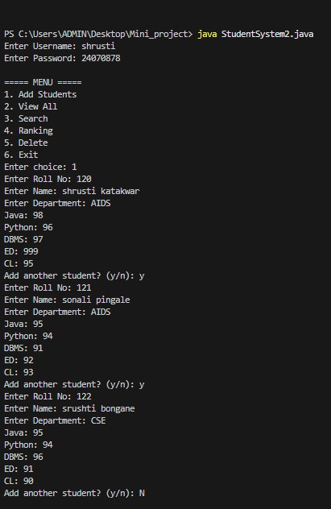

To view all students and search them by roll no. :
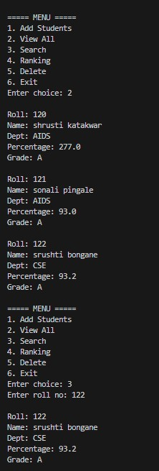

To establish learning ambience for ushering in computer engineering professionals in core and multidisciplinary area by developing Problemsolving skills through emerging technologies.

To give ranking and deletion :
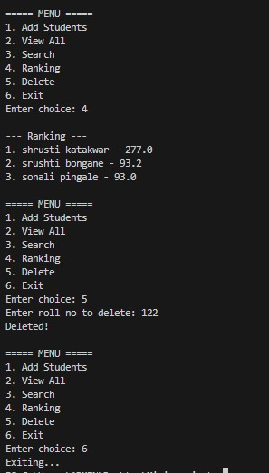
Output Analysis | The program executes in a menu-driven format after successful login. It allows the user to interact with the system and perform various operations on student data.
1. Login Output
- If correct username and password are entered → Access granted and menu displayed
- If incorrect → Displays "Invalid Login!" and program terminates
2. Add Student Output
• User enters student details (roll, name, marks, etc.) • System calculates:
o Percentage
To establish learning ambience for ushering in computer engineering professionals in core and multidisciplinary area by developing Problemsolving skills through emerging technologies.

 |  | o Grade (A/B/C/F)
 | • | Multiple student entries are allowed
 |  | 3. View All Output
 | • | Displays details of all students: o Roll Number o Name o Department o Percentage o Grade
 |  | 4. Search Output
 | • | User enters roll number
 | • | If found → Student details displayed
 | • | If not found → Displays "Not Found!"
 |  | 5. Ranking Output
 | • | Students are sorted based on percentage (highest first)
 | • | Displays ranked list:  o Rank number o Student name o Percentage
 |  | 6. Delete Output
 | • | User enters roll number
 | • | If found → Student record deleted and "Deleted!" shown
 | • | If not found → Displays "Not Found!"
7. Error Handling Output
• If invalid input (like string instead of number): o Displays "Invalid Input!" o Prevents program crash
8. Exit Output
• Displays "Exiting..." and program stops

Link of student Github profile where lab assignment has been uploaded
Conclusion | The Student Management System successfully demonstrates the implementation of core Java programming concepts such as objectoriented programming, arrays, control statements, exception handling, and sorting techniques. The program provides an efficient way to manage student records by allowing operations like adding, viewing, searching, ranking, and deleting student data. It ensures accurate calculation of percentage and grades while maintaining data integrity through proper input validation and error handling. The menu-driven approach makes the system userfriendly and easy to operate.  Overall, the program reduces manual effort, improves data organization, and serves as a practical example of applying programming concepts to solve real-world problems.

To be a well-known centre for pursuing computer education through innovative pedagogy, value-based education and industry collaboration. Mission of the Department
To establish learning ambience for ushering in computer engineering professionals in core and multidisciplinary area by developing Problemsolving skills through emerging technologies.

Department of Computer Technology
Vision of the Department
To be a well-known centre for pursuing computer education through innovative pedagogy, value-based education and industry collaboration. Mission of the Department
To establish learning ambience for ushering in computer engineering professionals in core and multidisciplinary area by developing Problemsolving skills through emerging technologies.

Plag Report
(Similarity index <
12%)
Date | 01/04/26

